JS-Control flows

**Date: 18-05-2024**

1. Write a program to check eligible to vote. (eligible to vote if age 18+)
   * age = 24;
   * **Display message: "You are eligible to vote"**

let age=24;

if (age > 18)

{

    console.log("You are elegible to vote");

}

1. Write a program to check whether a given number is even or odd.
   * num = 27;
   * **Display message: "Number {num} is odd/ even"**

let num=27;

let remainder = (num%2);

if (remainder = 1)

{

    console.log("The "+ num +" is odd");

}

else {

    console.log("The "+ num +" is even");

}

1. Write a program that displays the largest integer among two integers.
   * num1 = 10;
   * num2 = 2;
   * **Display message: "{num1} is large than {num2}"**

let num1 = 10, num2 = 2;

if (num1 > num2)

{

    console.log(num1 + " is larger than " + num2);

}

else

{

    console.log(num2 + " is larger than " + num1)

}

1. Write a program that determines if a year is a leap year.
   * year = 2024;
   * **Display message: "{year} is leap year"**

let year = 2024;

let div4 = (year%4), div100 = (year%100), div400 = (year%400);

if ((div4==0 && div400==0) || div100!=0)

{

    console.log(year + " is leap year");

}

1. Write a program to check alphabet it is vowel or consonant using switch case.
   * alphabet = 'a';
   * **Display message: "{alphabet } is vowel/ consonant"**

let alphabet = "a"

switch (alphabet)

{

    case "a":

        console.log(alphabet + " is a vowel");

    break;

    case "e":

        console.log(alphabet + " is a vowel");

    break;

    case "i":

        console.log(alphabet + " is a vowel");

    break;

    case "o":

        console.log(alphabet + " is a vowel");

    break;

    case "u":

        console.log(alphabet + " is a vowel");

    break;

    default:

        console.log(alphabet + " is a consonant");

}

1. Write a program to compute the sum of the first 10 natural numbers using a **for** loop.
   * **Display message: "The first {number} number's sum is {sum}."**

let num = 0;

for (let i=1; i<=10; i++)

{

    num+=i;

}

console.log(`The first 10 number's sum is ${num}`);

1. Write a program to print given shapes.
   * **For loop**

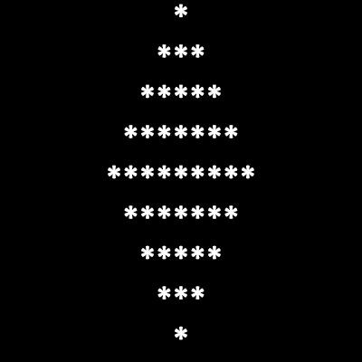

* + **while loop**

